

BUS BOOKING APPLICATION

MINI PROJECT REPORT

Submitted by

GUHAN S (9517202209016)
JAICHANDRAN S (9517202209021)
PERUMAL B (9517202209041)
SATHIESH PRABHU R (9517202209051)

in

19AD652–FULLSTACK DEVELOPMENT LABORATORY

DEPARTMENT OF ARTIFICIAL INTELLIGENCE AND DATA SCIENCE

MEPCO SCHLENK ENGINEERING COLLEGE SIVAKASI

MAY 2025

MEPCO SCHLENK ENGINEERING COLLEGE, SIVAKASI AUTONOMOUS
DEPARTMENT OF ARTIFICIAL INTELLIGENCE AND DATA SCIENCE



BONAFIDE CERTIFICATE

This is to certify that it is the bonafide work of “GUHAN S (9517202209016), JAICHANDRAN S(9517202209021),PERUMAL B(9517202209041), SATHIESH PRABHU R (9517202209051)” for the mini project titled “BUS BOOKING APPLICATION” in 19AD652-FULLSTACK DEVELOPMENT LABORATORY during the sixth Semester January 2025 – May 2025 under my supervision.

SIGNATURE SIGNATURE

Dr.J.Angela Jennifa Sujana,M.E.,Ph.D Dr.J.Angela Jennifa Sujana,M.E.,Ph.D
Professor & Head, Professor & Head,
AI&DS Department, AI&DS Department,
Mepco Schlenk Engg. College, Sivakasi Mepco Schlenk Engg. College, Sivakasi.

ABSTRACT

The Bus Booking Application is a web-based application designed to streamline the process of booking bus seats for users. It provides a user-friendly interface for registration, login, seat selection, and booking confirmation. The system integrates a MySQL database for storing user information, bus details, and booking records, with a Node.js backend using Express.js for handling API requests. The frontend is built using HTML, CSS, and JavaScript, offering an interactive seat selection interface. The primary goal is to enhance user experience by providing a secure, efficient, and accessible platform for bus reservations. This project demonstrates the integration of modern web technologies to address real-world booking needs.The Bus Booking Application is a sophisticated web platform aimed at revolutionizing bus seat reservations. It enables users to register, authenticate, choose seats, and finalize bookings through an accessible and engaging interface. The system is powered by a Node.js backend with Express.js for seamless API operations and a MySQL database for reliable data management. The frontend, utilizing HTML, CSS, and JavaScript, delivers a dynamic and responsive user experience, particularly in seat selection. By automating booking processes, ensuring real-time seat updates, and prioritizing user security, the application addresses the inefficiencies of traditional booking methods, showcasing the potential of web technologies to transform transportation logistics. The backend, built using Node.js and Express.js, handles API requests efficiently, while a MySQL database securely stores user data, bus configurations, and booking details. The frontend, crafted with HTML, CSS, and JavaScript, offers a responsive and interactive seat selection module. This application ensures real-time seat availability, robust error handling, and a streamlined booking process, making it a valuable tool for users and a testament to the integration of modern web technologies in enhancing transportation services.

TABLE OF CONTENT

CHAPTER NO | TITLE |  | PAGE NO
 | ABSTRACT |  | 3
1 | INTRODUCTION
 | 1 | Overview | 6
 | 1 | Objectives | 7
 | 1 | Scope of the Project | 7
 | 1 | Modules Used | 8
 | 1 | Working | 9
2 | PROPOSED SYSTEM
 | 2 | System Design | 12
3 | SYSTEM REQUIREMENTS |  | 13
4 | IMPLEMENTATION
 | 4 | Source Code | 15
 | 4 | Results | 36
5 | CONCLUSION |  | 39
6 | REFERENCES |  | 40

ACKNOWLEDGEMENT

First and foremost we praise and thank “The Almighty”, the lord of all creations, who by his abundant grace has sustained us and helped us to work on this project successfully.
We really find unique pleasure and immense gratitude in thanking our respected management members, who is the backbone of our college.
A deep bouquet of thanks to respected Principal Dr. S.Arivazhagan M.E.,Ph.D., for having provided the facilities required for our mini project.
We sincerely thank our Head of the Department Dr. J.Angela Jennifa Sujana M.E.,Ph.D., Professor & Head, Department of Artificial Intelligence and Data Science, for her guidance and support throughout the mini project .
We also thank our guide Mrs. A.MuthuLakshmi M.Tech., Assistant Professor, Mrs. M.Revatheeswari M.Tech, Assistant Professor and Dr. J.Angela Jennifa Sujana M.E.,Ph.D , Professor & Head, Department of Artificial Intelligence and Data Science for their valuable guidance and it is great privilege to express our gratitude to them.
We extend our heartfelt thanks and profound gratitude to all the faculty members of Artificial Intelligence and Data Science department for their kind help during our mini project work.
We also thank our parents and our friends who had been providing us with constant support during the course of the mini project work.

CHAPTER 1

INTRODUCTION
  - OVERVIEW
The Bus Booking Application is a web-based application designed to streamline the process of booking bus seats for users. It provides a user-friendly interface for registration, login, seat selection, and booking confirmation. The system integrates a MySQL database for storing user information, bus details, and booking records, with a Node.js backend using Express.js for handling API requests. The frontend is built using HTML, CSS, and JavaScript, offering an interactive seat selection interface. The primary goal is to enhance user experience by providing a secure, efficient, and accessible platform for bus reservations. This project demonstrates the integration of modern web technologies to address real-world booking needs.

1.2 OBJECTIVES

The primary goal of the Bus Booking Application is to create a user-friendly and efficient platform for booking bus seats. The application aims to provide an intuitive interface that simplifies the reservation process for users of all technical backgrounds. It seeks to ensure secure user registration and authentication, protecting user data while allowing seamless access to booking features. Another objective is to enable users to view available buses and select seats for specific travel dates, with real-time updates to prevent booking conflicts. The system also focuses on efficiently storing and managing booking details in a MySQL database, ensuring data accuracy and accessibility. Finally, the application strives to generate detailed booking confirmations, enhancing user trust and satisfaction by providing clear reservation details.
The main objectives of the Bus Booking Application are:
- To provide a user-friendly interface for bus booking.
- To enable secure user registration and authentication.
- To allow users to view available buses and select seats for specific dates.
- To store and manage booking details efficiently in a database.
- To ensure real-time updates of seat availability to prevent double bookings.
- To generate booking confirmations with detailed information for users.

1.3 SCOPE OF THE PROJECT

The Bus Booking Application encompasses a range of functionalities designed to streamline bus reservations. It includes user management features, allowing individuals to register and log in securely using their email and password. The system supports bus management by displaying available buses and their seat configurations, although it currently operates with a single default bus. Booking management is a core component, enabling users[to select seats, confirm bookings, and retrieve reservation details. The application integrates a MySQL database to store user, bus, and booking data, ensuring efficient data handling. The frontend offers a responsive interface for seat selection and form submission, while the backend provides RESTful APIs for processing user requests. However, the system is limited to bus bookings with a predefined configuration and does not include payment processing or advanced scheduling features, which could be explored in future iterations.

1.4 MODULES USED

The Bus Booking Application is structured into several key modules that work together to deliver a cohesive booking experience. The user authentication module handles registration and login, ensuring secure access to the system through email and password verification. The bus listing module retrieves and displays available buses from the database, providing users with options for their travel needs. The seat selection module allows users to view and choose available seats for a specific date, with a visual interface that highlights booked and available seats. The booking module processes reservation requests, validates seat availability, and stores booking details in the database. The booking confirmation module presents users with detailed reservation information after a successful booking, enhancing transparency. Finally, the database module manages data storage and retrieval, leveraging MySQL to ensure efficient and secure data operations.

- Node.js: This is the runtime environment for the backend, enabling the development of a scalable and efficient server-side application. Node.js uses JavaScript to execute server-side logic, supporting asynchronous operations that handle multiple user requests, such as registration, login, and booking submissions, without blocking the server.
- Express.js: A minimalist web framework for Node.js, Express.js is used to create RESTful APIs that manage HTTP requests and responses. It simplifies the development of API endpoints for user authentication, bus data retrieval, and booking operations, while providing middleware support for tasks like CORS handling and JSON parsing, facilitating seamless communication between the frontend and backend.
- HTML: Hyper Text Markup Language forms the structural backbone of the frontend, defining the layout of pages such as login, registration, and booking interfaces. HTML ensures that content is organized and accessible, providing a foundation for the application's user interface and enabling proper rendering across different devices and browsers.
- CSS: Cascading Style Sheets are used to style the application's frontend, enhancing its visual appeal and usability. CSS defines the look and feel of elements like the seat selection map, forms, and buttons, ensuring a responsive design that adapts to various screen sizes and provides a consistent, user-friendly experience.
- JavaScript: This programming language powers the dynamic functionality of the frontend, enabling interactive features such as real-time seat selection, form validation, and asynchronous API calls. JavaScript handles client-side logic, such as fetching booked seats or submitting booking requests, making the application responsive and engaging for users.
- MySQL: This relational database management system serves as the backend database, securely storing and managing user profiles, bus configurations, and booking records. MySQL handles data operations through structured queries, ensuring efficient storage, retrieval, and updating of information, such as user credentials, seat availability, and booking details, while maintaining data integrity and supporting the application's scalability.

1.5 WORKING

The Bus Booking Application operates through a series of interconnected steps that guide users from registration to booking confirmation. Initially, new users register by providing an email and password, which are securely stored in the MySQL database. Registered users log in with their credentials, and their session is saved in local storage for seamless navigation. Upon logging in, users can view available buses—currently a single default bus with 40 seats—and select a travel date. The system fetches booked seats for the chosen date and displays a seat map, where users can select available seats, visually indicated by distinct colors. After selecting seats, users complete a booking form with details such as name, age, and additional information, which the system validates before storing in the database. Upon successful booking, users are redirected to a confirmation page displaying their reservation details in a tabular format. Users can log out at any time, clearing their session from local storage to security. The Bus Booking Application operates as a cohesive system that guides users through a streamlined process from registration to booking confirmation, leveraging its modular architecture to ensure efficiency and usability.
- User Registration: New users begin by registering through a form where they provide a unique email and password. The frontend, built with HTML and styled with CSS, presents a clean interface for data entry, while JavaScript validates the input. The data is sent to the backend via an Express.js API endpoint (/api/register), where Node.js processes the request, checks for existing users in the MySQL database, and stores the new user’s credentials securely if the email is unique.
- Login: Registered users log in using their email and password through a dedicated login page, structured with HTML and styled with CSS. JavaScript handles form validation and sends the credentials to the backend via the /api/login endpoint. Node.js, running on the Express.js framework, queries the MySQL database to verify the credentials, and upon successful authentication, the user’s session is stored in local storage for subsequent interactions.
- Booking: After logging in, users access the booking page, where they select a travel date and view a seat map for a default bus (40 seats). The frontend, powered by HTML, CSS, and JavaScript, displays a 2x2 seat layout with an aisle, fetching booked seats from the backend via the /api/booked-seats/:vehicleId/:date endpoint. Users select available seats, which JavaScript highlights visually, and complete a booking form with details like name, age, and additional information. The form data, along with selected seats, is sent to the /api/booking endpoint, where Node.js validates seat availability, stores the booking in the MySQL database, and updates the bus’s availability status.
- Show Result: Upon successful booking, users are redirected to a confirmation page (thankyou.html), which displays booking details in a tabular format, including name, bus name, date, seat numbers, age, passenger count, and additional details. The frontend, using HTML and CSS, presents the data clearly, while JavaScript fetches the booking information from the /api/booking/:userId endpoint, processed by Node.js and Express.js, ensuring users receive accurate and comprehensive reservation details.
- Logout: Users can log out at any time, clearing their session from local storage to ensure security. The logout functionality is implemented on the frontend using JavaScript, which removes the stored user session and

CHAPTER 2

PROPOSED SYSTEM
2.1. SYSTEM DESIGN
The Bus Booking Application is designed with a client-server architecture to ensure scalability and efficiency. The frontend, built using HTML, CSS, and JavaScript, provides a responsive and interactive interface, featuring a 2x2 seat selection layout with an aisle for visual clarity. CSS styling enhances the user experience by distinguishing available, booked, and selected seats. The backend, developed with Node.js and Express.js, manages API requests for user authentication, bus data retrieval, seat availability checks, and booking operations. A MySQL database stores critical data, including user profiles, bus details, and booking records, with a schema comprising tables for users, vehicles, and bookings. Key API endpoints include /api/register for user registration, /api/login for authentication, /api/vehicles for bus data, /api/booked-seats/:vehicleId/:date for seat availability, /api/booking/:userId for booking details, and /api/booking for creating reservations. The system flow begins with user interactions on the frontend, which trigger API requests to the backend. The backend processes these requests, queries the database, and returns responses to update the frontend, ensuring a seamless and real-time booking experience.

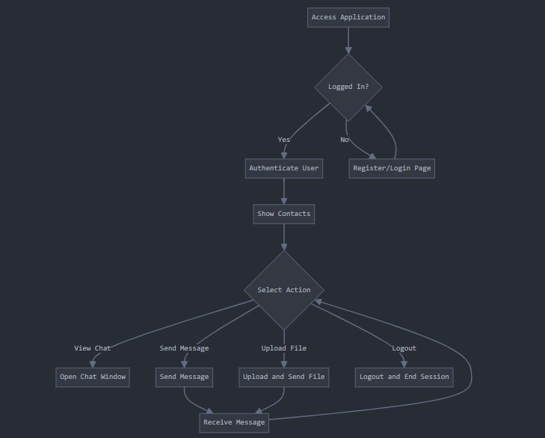

Fig: 2.1 System Design

CHAPTER 3

SYSTEM REQUIREMENTS
3.1 SOFTWARE REQUIREMENTS

The Bus Booking Application requires specific hardware and software to ensure smooth development, testing, and deployment. On the hardware side, a processor like Intel Core i3 or higher is recommended, paired with at least 4 GB of RAM and 500 MB of free disk space. A stable internet connection is essential for development and testing. For software, the application is compatible with Windows, macOS, or Linux operating systems and runs on modern web browsers such as Google Chrome or Mozilla Firefox. The backend relies on Node.js (version 16 or higher) and MySQL (version 8 or higher), with npm used for package management. The frontend requires a code editor like Visual Studio Code and uses vanilla HTML, CSS, and JavaScript without additional frameworks. Key dependencies include Express.js for API handling, MySQL2 for database connectivity, CORS for cross-origin requests, and dotenv for environment variable management. MySQL Workbench or a similar tool is recommended for database administration, ensuring efficient management of the application's data.
- Hardware Requirements:
  - Processor: Intel Core i3 or higher, to support efficient execution of development tools and the application.
  - RAM: Minimum 4 GB, to handle multiple processes during development and testing.
  - Disk Space: At least 500 MB of free disk space, for storing project files, dependencies, and the database.
  - Internet Connection: Stable internet connection, required for downloading dependencies and testing API interactions.
- Software Requirements:
  - Operating System: Windows, macOS, or Linux, to provide a compatible environment for development and deployment.
  - Web Browser: Modern browsers such as Google Chrome or Mozilla Firefox, for testing the frontend interface.
  - Node.js: Version 16 or higher, to run the backend server and manage JavaScript-based server-side logic.
  - MySQL: Version 8 or higher, to serve as the relational database for storing application data.
  - npm: Node Package Manager, for installing and managing project dependencies like Express.js and MySQL2.
  - Code Editor: Visual Studio Code or similar, for writing and editing HTML, CSS, JavaScript, and backend code.
  - Dependencies:
    - Express.js: For creating RESTful APIs and handling HTTP requests.
    - MySQL2: For seamless connectivity between Node.js and the MySQL database.
    - CORS: To enable cross-origin resource sharing between the frontend and backend.
    - dotenv: For managing environment variables securely.
- Database Tool: MySQL Workbench or similar, for efficient database administration and query management.

CHAPTER 4

IMPLEMENTATION
4.1. SOURCE CODE
Server.js:
const express = require('express');
const cors = require('cors');
const mysql = require('mysql2');
const path = require('path');
require('dotenv').config();

const app = express();
app.use(cors());
app.use(express.json());
app.use(express.static('public')); // Serve static HTML/CSS/JS

// Create MySQL connection
const db = mysql.createConnection({
host: 'localhost',
user: 'root',
password: 'guhanmepco',
database: 'vehicle_booking'
});

// Connect to the database
db.connect((err) => {
if (err) {
console.error('Error connecting to the database:', err);
} else {
console.log('Connected to the MySQL database');
}
});

// Register user API
app.post('/api/register', (req, res) => {
const { email, password } = req.body;

// Check if the user already exists
db.query('SELECT * FROM users WHERE email = ?', [email], (err, results) => {
if (err) {
return res.json({ success: false, message: 'Database error' });
}

if (results.length > 0) {
return res.json({ success: false, message: 'User already exists' });
}

// Insert new user into the database
db.query('INSERT INTO users (email, password) VALUES (?, ?)', [email, password], (err) => {
if (err) {
console.error(err);
return res.json({ success: false, message: 'Registration failed' });
}
res.json({ success: true });
});
});
});

// Login API
app.post('/api/login', (req, res) => {
const { email, password } = req.body;

db.query('SELECT * FROM users WHERE email = ? AND password = ?', [email, password], (err, results) => {
if (err) {
return res.json({ success: false, message: 'Database error' });
}

if (results.length > 0) {
res.json({ success: true, user: results[0] });
} else {
res.json({ success: false, message: 'Invalid email or password' });
}
});
});

// Get Available Vehicles
app.get('/api/vehicles', (req, res) => {
db.query('SELECT * FROM vehicles WHERE available = 1', (err, results) => {
if (err) {
return res.json({ success: false, message: 'Database error' });
}
res.json(results);
});
});

// Get Booked Seats for a Vehicle and Date
app.get('/api/booked-seats/:vehicleId/:date', (req, res) => {
const { vehicleId, date } = req.params;
const formattedDate = date.split('T')[0]; // Extract YYYY-MM-DD

db.query(
'SELECT seat_numbers FROM bookings WHERE vehicle_id = ? AND DATE(date) = ?',
[vehicleId, formattedDate],
(err, results) => {
if (err) {
return res.json({ success: false, message: 'Database error' });
}

const bookedSeats = [];
results.forEach(row => {
if (row.seat_numbers) {
bookedSeats.push(...row.seat_numbers.split(',').map(Number));
}
});

res.json({ success: true, bookedSeats });
}
);
});

// Check Existing Booking
app.get('/api/booking/:userId', (req, res) => {
const userId = req.params.userId;

db.query(`
SELECT b.*, v.name AS vehicle_name
FROM bookings b
JOIN vehicles v ON b.vehicle_id = v.id
WHERE b.user_id = ?
`, [userId], (err, results) => {
if (err) {
return res.json({ success: false, message: 'Database error' });
}

if (results.length > 0) {
// Include seat numbers in the response
results = results.map(booking => ({
...booking,
seat_numbers: booking.seat_numbers ? booking.seat_numbers.split(',').map(Number) : []
}));
res.json({ success: true, booking: results[0] });
} else {
res.json({ success: true, booking: null });
}
});
});

// Book a Vehicle
app.post('/api/booking', (req, res) => {
const { userId, vehicleId, date, name, age, noOfPassengers, selectedSeats, additionalDetails } = req.body;

// Validate input
if (!userId || !vehicleId || !date || !selectedSeats || selectedSeats.length === 0) {
return res.json({ success: false, meeting: 'Missing required fields' });
}

// Check if any selected seats are already booked for the same vehicle and date
const formattedDate = date.split(' ')[0]; // Extract YYYY-MM-DD
db.query(
'SELECT seat_numbers FROM bookings WHERE vehicle_id = ? AND DATE(date) = ?',
[vehicleId, formattedDate],
(err, results) => {
if (err) {
return res.json({ success: false, message: 'Database error' });
}

const bookedSeats = [];
results.forEach(row => {
if (row.seat_numbers) {
bookedSeats.push(...row.seat_numbers.split(',').map(Number));
}
});

const alreadyBooked = selectedSeats.filter(seat => bookedSeats.includes(seat));
if (alreadyBooked.length > 0) {
return res.json({
success: false,
message: `Seats ${alreadyBooked.join(', ')} are already booked for this date.`
});
}

// Insert booking into the bookings table
const seatNumbersString = selectedSeats.join(',');
db.query(
'INSERT INTO bookings (user_id, vehicle_id, date, seat_numbers, name, age, no_of_passengers, additional_details) VALUES (?, ?, ?, ?, ?, ?, ?, ?)',
[userId, vehicleId, date, seatNumbersString, name, age, noOfPassengers, additionalDetails],
(err) => {
if (err) {
console.error(err);
return res.json({ success: false, message: 'Booking failed' });
}

// Mark vehicle as unavailable (optional, depending on requirements)
db.query('UPDATE vehicles SET available = 0 WHERE id = ?', [vehicleId], (err) => {
if (err) {
return res.json({ success: false, message: 'Unable to update vehicle availability' });
}
res.json({ success: true });
});
}
);
}
);
});

// Start the server
app.listen(5000, () => {
console.log('Server running on http://localhost:5000/login.html');
});

Booking.HTML
<!DOCTYPE html>
<html>
<head>
<title>Bus Booking</title>
<link rel="stylesheet" href="style.css">
<style>
.form-group {
margin-bottom: 10px;
}
label {
display: block;
margin: 5px 0;
}
input, select, textarea {
width: 100%;
padding: 8px;
margin-top: 5px;
box-sizing: border-box;
}
button {
padding: 10px 15px;
background-color: #4CAF50;
color: white;
border: none;
cursor: pointer;
}
button:hover {
background-color: #45a049;
}
/* Bus Seat Layout Styles */
.bus-container {
background-color: #f8f8f8;
border: 2px solid #ccc;
border-radius: 10px;
padding: 20px;
width: 300px;
margin: 20px auto;
position: relative;
}
.seat {
width: 30px;
height: 30px;
background-color: #ddd;
border: 1px solid #999;
border-radius: 5px;
display: inline-block;
margin: 5px;
text-align: center;
line-height: 30px;
cursor: pointer;
position: relative;
}
.seat.available:hover {
background-color: #b3e6b3;
}
.seat.selected {
background-color: #4CAF50;
color: white;
}
.seat.occupied {
background-color: #ff3333;
cursor: not-allowed;
color: white;
}
.seat.occupied::after {
content: 'X';
position: absolute;
top: 0;
left: 0;
width: 100%;
height: 100%;
display: flex;
align-items: center;
justify-content: center;
font-weight: bold;
}
.seat-row {
display: flex;
justify-content: space-between;
margin-bottom: 10px;
}
.aisle {
width: 20px;
display: inline-block;
}
.driver {
position: absolute;
top: 10px;
right: 10px;
font-size: 12px;
font-weight: bold;
}
</style>
</head>
<body>
<div class="container">
<h2>Bus Booking</h2>

<h3>Bus Seat Selection</h3>
<div id="seatSelection">
<div class="form-group">
<label for="date">Select Date:</label>
<input type="date" id="date" required>
</div>
<div class="bus-container">
<div class="driver"></div>
<div id="seatMap"></div>
</div>
</div>

<h3>Booking Form</h3>
<form id="bookingForm" style="display:none;">
<div class="form-group">
<label for="name">Name:</label>
<input type="text" id="name" required>
</div>
<div class="form-group">
<label for="age">Age:</label>
<input type="number" id="age" required>
</div>
<div class="form-group">
<label for="noOfPassengers">Number of Passengers:</label>
<input type="number" id="noOfPassengers" required readonly>
</div>
<div class="form-group">
<label for="additionalDetails">Additional Details:</label>
<textarea id="additionalDetails" rows="4"></textarea>
</div>
<button type="button" onclick="submitBooking()">Confirm Booking</button>
</form>
</div>

<script>
let selectedSeats = [];
const user = JSON.parse(localStorage.getItem('user'));
const defaultVehicle = { id: 1, name: 'Standard Bus', seats: 40 }; // Default bus configuration

// Function to load the page and set up date input
function loadPage() {
if (!user) {
alert('Please log in to book a vehicle.');
window.location.href = 'login.html';
return;
}

// Set min date to today
const today = new Date().toISOString().split('T')[0];
document.getElementById('date').setAttribute('min', today);
document.getElementById('date').value = today;

// Generate seat map for today's date
fetchBookedSeats(today, () => generateSeatMap(defaultVehicle.seats));

// Add event listener for date change
document.getElementById('date').addEventListener('change', (e) => {
const selectedDate = e.target.value;
fetchBookedSeats(selectedDate, () => generateSeatMap(defaultVehicle.seats));
});
}

// Function to fetch booked seats for a specific date
function fetchBookedSeats(date, callback) {
fetch(`/api/booked-seats/${defaultVehicle.id}/${date}`)
.then(response => response.json())
.then(data => {
if (data.success) {
window.bookedSeats = data.bookedSeats || [];
} else {
window.bookedSeats = [];
console.error('Error fetching booked seats:', data.message);
}
callback();
})
.catch(error => {
console.error('Error fetching booked seats:', error);
window.bookedSeats = [];
callback();
});
}

// Function to generate seat map (2x2 layout with aisle)
function generateSeatMap(totalSeats) {
const seatMap = document.getElementById('seatMap');
seatMap.innerHTML = '';
selectedSeats = [];
document.getElementById('noOfPassengers').value = 0;
document.getElementById('bookingForm').style.display = 'none';

const rows = Math.ceil(totalSeats / 4);
for (let i = 0; i < rows; i++) {
const rowDiv = document.createElement('div');
rowDiv.className = 'seat-row';

for (let j = 1; j <= 4; j++) {
const seatNumber = i * 4 + j;
if (seatNumber > totalSeats) break;

const seat = document.createElement('div');
const isBooked = window.bookedSeats.includes(seatNumber);
seat.className = isBooked ? 'seat occupied' : 'seat available';
seat.innerText = seatNumber;
if (!isBooked) {
seat.onclick = () => toggleSeat(seat, seatNumber);
}
rowDiv.appendChild(seat);

if (j === 2) {
const aisle = document.createElement('div');
aisle.className = 'aisle';
rowDiv.appendChild(aisle);
}
}
seatMap.appendChild(rowDiv);
}
}

// Function to toggle seat selection
function toggleSeat(seat, seatNumber) {
if (seat.classList.contains('occupied')) return;

if (seat.classList.contains('selected')) {
seat.classList.remove('selected');
selectedSeats = selectedSeats.filter(num => num !== seatNumber);
document.getElementById('bookingForm').style.display = 'none';
} else {
seat.classList.add('selected');
selectedSeats.push(seatNumber);
document.getElementById('bookingForm').style.display = 'block';
}

document.getElementById('noOfPassengers').value = selectedSeats.length;
}

// Function to handle booking submission
function submitBooking() {
const name = document.getElementById('name').value;
const age = document.getElementById('age').value;
const noOfPassengers = document.getElementById('noOfPassengers').value;
const date = document.getElementById('date').value;
const additionalDetails = document.getElementById('additionalDetails').value;

if (!name || !age || !noOfPassengers || !date) {
alert('Please fill in all required fields.');
return;
}

fetch('/api/booking', {
method: 'POST',
headers: { 'Content-Type': 'application/json' },
body: JSON.stringify({
userId: user.id,
vehicleId: defaultVehicle.id,
date: date, // Send only date (YYYY-MM-DD)
name: name,
age: age,
noOfPassengers: noOfPassengers,
selectedSeats: selectedSeats,
additionalDetails: additionalDetails
})
})
.then(response => response.json())
.then(data => {
if (data.success) {
window.location.href = 'thankyou.html';
} else {
alert(`Booking failed: ${data.message || 'Please try again.'}`);
}
})
.catch(error => {
console.error('Error submitting booking:', error);
alert('An error occurred. Please try again.');
});
}

window.onload = loadPage;
</script>
<script>(function(){function c(){var b=a.contentDocument||a.contentWindow.document;if(b){var d=b.createElement('script');d.innerHTML="window.__CF$cv$params={r:'9345def5aec3add8',t:'MTc0NTMzMjc3MC4wMDAwMDA='};var a=document.createElement('script');a.nonce='';a.src='/cdn-cgi/challenge-platform/scripts/jsd/main.js';document.getElementsByTagName('head')[0].appendChild(a);";b.getElementsByTagName('head')[0].appendChild(d)}}if(document.body){var a=document.createElement('iframe');a.height=1;a.width=1;a.style.position='absolute';a.style.top=0;a.style.left=0;a.style.border='none';a.style.visibility='hidden';document.body.appendChild(a);if('loading'!==document.readyState)c();else if(window.addEventListener)document.addEventListener('DOMContentLoaded',c);else{var e=document.onreadystatechange||function(){};document.onreadystatechange=function(b){e(b);'loading'!==document.readyState&&(document.onreadystatechange=e,c())}}}})();</script>
</body>
</html>

Login.HTML
<!DOCTYPE html>
<html lang="en">
<head>
<meta charset="UTF-8">
<meta name="viewport" content="width=device-width, initial-scale=1.0">
<title>Login</title>
<link rel="stylesheet" href="style.css">
</head>
<body>
<div class="container login-container">
<div class="login-header">
<img src="logo.jpg" alt="Vehicle Booking Logo" class="logo" style="width: 120px;">
<h2>Login to Your Account</h2>
</div>
<form id="loginForm">
<div class="form-group">
<label for="email">Email</label>
<input id="email" type="email" placeholder="Enter your email" required>
</div>
<div class="form-group">
<label for="password">Password</label>
<input id="password" type="password" placeholder="Enter your password" required>
</div>
<button type="button" onclick="login()">Login</button>
</form>
<h3>New user? <a href="register.html" class="button">Register here</a></h3>
</div>

<script>
function login() {
const email = document.getElementById('email').value;
const password = document.getElementById('password').value;

if (!email || !password) {
alert("Please fill in both fields.");
return;
}

fetch('/api/login', {
method: 'POST',
headers: { 'Content-Type': 'application/json' },
body: JSON.stringify({ email, password })
})
.then(res => res.json())
.then(data => {
if (data.success) {
console.log("Login successful", data);
localStorage.setItem('user', JSON.stringify(data.user));
window.location.href = 'booking.html';
} else {
alert('Login failed');
}
})
.catch(error => {
console.error("Error during login request:", error);
alert("An error occurred while trying to log in.");
});
}
</script>
<script>(function(){function c(){var b=a.contentDocument||a.contentWindow.document;if(b){var d=b.createElement('script');d.innerHTML="window.__CF$cv$params={r:'9345def6eeab7b91',t:'MTc0NTMzMjc3MC4wMDAwMDA='};var a=document.createElement('script');a.nonce='';a.src='/cdn-cgi/challenge-platform/scripts/jsd/main.js';document.getElementsByTagName('head')[0].appendChild(a);";b.getElementsByTagName('head')[0].appendChild(d)}}if(document.body){var a=document.createElement('iframe');a.height=1;a.width=1;a.style.position='absolute';a.style.top=0;a.style.left=0;a.style.border='none';a.style.visibility='hidden';document.body.appendChild(a);if('loading'!==document.readyState)c();else if(window.addEventListener)document.addEventListener('DOMContentLoaded',c);else{var e=document.onreadystatechange||function(){};document.onreadystatechange=function(b){e(b);'loading'!==document.readyState&&(document.onreadystatechange=e,c())}}}})();</script>
</body>
</html>

Register .Html

<!DOCTYPE html>

<html lang="en">

<head>

<meta charset="UTF-8">

<meta name="viewport" content="width=device-width, initial-scale=1.0">

<title>Register</title>

<link rel="stylesheet" href="style.css">

</head>

<body>

<div class="container">

<h2>Register</h2>

<form id="registerForm">

<div class="form-group">

<label for="newEmail">Email</label>

<input id="newEmail" type="email" placeholder="Enter your email" required>

</div>

<div class="form-group">

<label for="newPassword">Password</label>

<input id="newPassword" type="password" placeholder="Create a password" required>

</div>

<button type="button" onclick="register()">Register</button>

</form>

<h3>Already have an account? <a href="login.html" class="button">Login here</a></h3>

</div>

<script>

function register() {

const email = document.getElementById('newEmail').value;

const password = document.getElementById('newPassword').value;

if (!email || !password) {

alert("Please fill in both fields.");

return;

}

fetch('/api/register', {

method: 'POST',

headers: { 'Content-Type': 'application/json' },

body: JSON.stringify({ email, password })

})

.then(res => res.json())

.then(data => {

if (data.success) {

alert("Registration successful! You can now log in.");

window.location.href = 'login.html';

} else {

alert('Registration failed');

}

})

.catch(error => {

console.error("Error during registration request:", error);

alert("An error occurred while trying to register.");

});

}

</script>

</body>

</html>

thankyou.html

<!DOCTYPE html>

<html lang="en">

<head>

<meta charset="UTF-8">

<meta name="viewport" content="width=device-width, initial-scale=1.0">

<title>Booking Confirmed</title>

<link rel="stylesheet" href="style.css">

</head>

<body>

<div class="container">

<h1>🎉 Booking Confirmed!</h1>

<p>Thank you for booking with us.</p>

<p>Your vehicle is now reserved. Below are your booking details:</p>

<h3>Booking Details</h3>

<table id="bookingTable">

<thead>

<tr>

<th>Name</th>

<th>Vehicle</th>

<th>Date & Time</th>

<th>Seat Numbers</th>

<th>Age</th>

<th>No. of Passengers</th>

<th>Additional Details</th>

</tr>

</thead>

<tbody id="bookingTableBody">

<!-- Booking details will be inserted here -->

</tbody>

</table>

<div style="margin-top: 20px;">

<button onclick="logout()" class="button">Logout</button>

</div>

</div>

<script>

// Fetch booking details when the page loads

window.onload = function () {

const user = JSON.parse(localStorage.getItem('user'));

if (!user || !user.id) {

alert('No user found. Please log in again.');

window.location.href = 'login.html';

return;

}

fetch(`/api/booking/${user.id}`)

.then(response => response.json())

.then(data => {

if (data.success && data.booking) {

displayBookingDetails(data.booking);

} else {

document.getElementById('bookingTableBody').innerHTML = `

<tr>

<td colspan="7">No booking details found.</td>

</tr>

`;

}

})

.catch(error => {

console.error('Error fetching booking details:', error);

alert('An error occurred while fetching booking details.');

});

// Disable back button

window.history.pushState(null, document.title, window.location.href);

window.onpopstate = function () {

window.history.pushState(null, document.title, window.location.href);

};

};

// Function to display booking details in the table

function displayBookingDetails(booking) {

const tableBody = document.getElementById('bookingTableBody');

tableBody.innerHTML = ''; // Clear any existing content

const row = document.createElement('tr');

row.innerHTML = `

<td>${booking.name || 'N/A'}</td>

<td>${booking.vehicle_name || 'N/A'}</td>

<td>${new Date(booking.date).toLocaleString()}</td>

<td>${booking.seat_numbers ? booking.seat_numbers.join(', ') : 'N/A'}</td>

<td>${booking.age || 'N/A'}</td>

<td>${booking.no_of_passengers || 'N/A'}</td>

<td>${booking.additional_details || 'N/A'}</td>

`;

tableBody.appendChild(row);

}

// Logout function

function logout() {

localStorage.removeItem('user');

window.location.replace('login.html'); // Replace history to prevent back

}

</script>

<script>(function(){function c(){var b=a.contentDocument||a.contentWindow.document;if(b){var d=b.createElement('script');d.innerHTML="window.__CF$cv$params={r:'9345def6ed54bfd6',t:'MTc0NTMzMjc3MC4wMDAwMDA='};var a=document.createElement('script');a.nonce='';a.src='/cdn-cgi/challenge-platform/scripts/jsd/main.js';document.getElementsByTagName('head')[0].appendChild(a);";b.getElementsByTagName('head')[0].appendChild(d)}}if(document.body){var a=document.createElement('iframe');a.height=1;a.width=1;a.style.position='absolute';a.style.top=0;a.style.left=0;a.style.border='none';a.style.visibility='hidden';document.body.appendChild(a);if('loading'!==document.readyState)c();else if(window.addEventListener)document.addEventListener('DOMContentLoaded',c);else{var e=document.onreadystatechange||function(){};document.onreadystatechange=function(b){e(b);'loading'!==document.readyState&&(document.onreadystatechange=e,c())}}}})();</script>

<script>(function(){function c(){var b=a.contentDocument||a.contentWindow.document;if(b){var d=b.createElement('script');d.innerHTML="window.__CF$cv$params={r:'934620d3cf80ad82',t:'MTc0NTMzNTQ2OC4wMDAwMDA='};var a=document.createElement('script');a.nonce='';a.src='/cdn-cgi/challenge-platform/scripts/jsd/main.js';document.getElementsByTagName('head')[0].appendChild(a);";b.getElementsByTagName('head')[0].appendChild(d)}}if(document.body){var a=document.createElement('iframe');a.height=1;a.width=1;a.style.position='absolute';a.style.top=0;a.style.left=0;a.style.border='none';a.style.visibility='hidden';document.body.appendChild(a);if('loading'!==document.readyState)c();else if(window.addEventListener)document.addEventListener('DOMContentLoaded',c);else{var e=document.onreadystatechange||function(){};document.onreadystatechange=function(b){e(b);'loading'!==document.readyState&&(document.onreadystatechange=e,c())}}}})();</script></body>

</html>

4.2 RESULTS
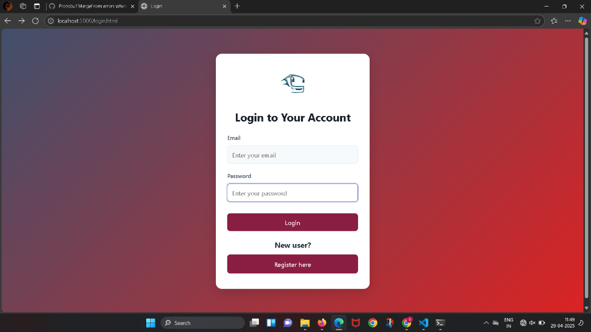

Fig: 4.2.1 Registration and Login Page
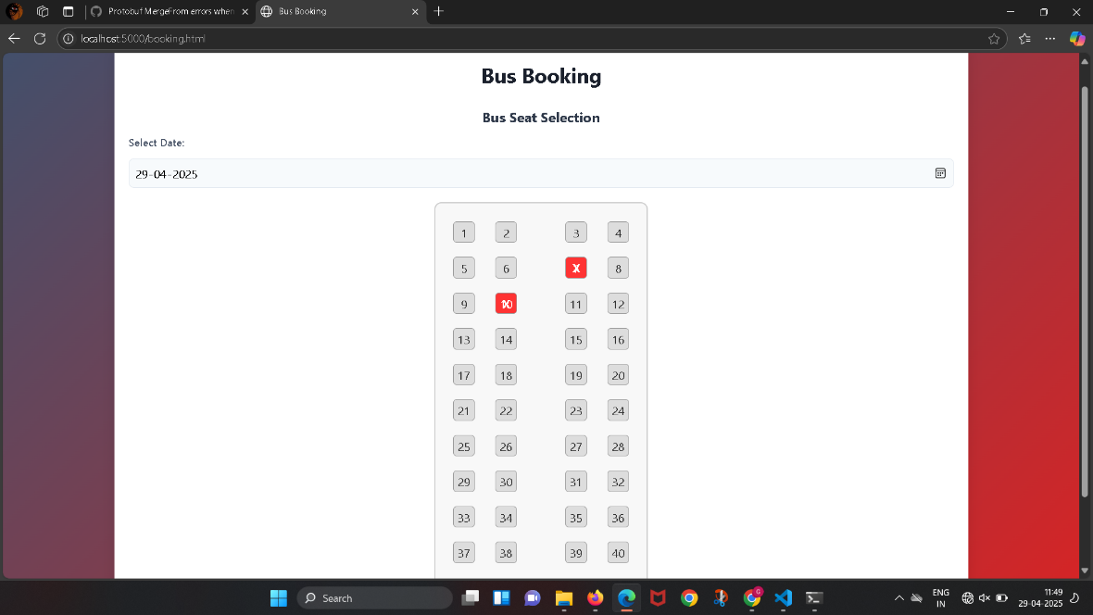

Fig: 4.2.2 Booking Page

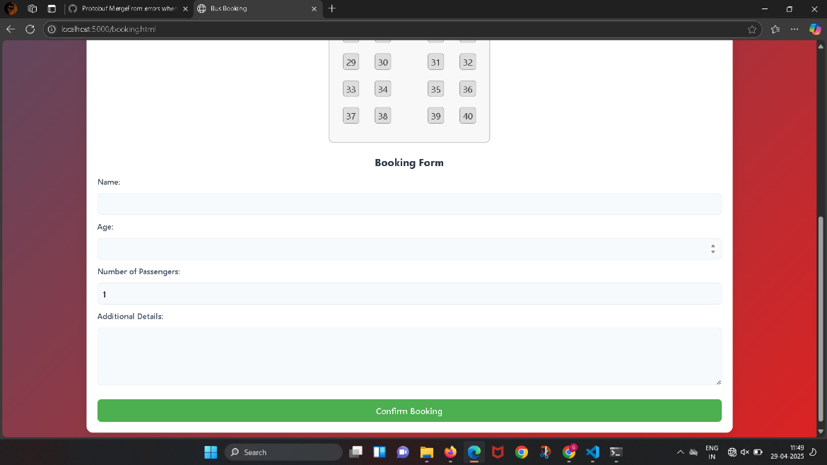

Fig: 4.2.3 Booking Details Page

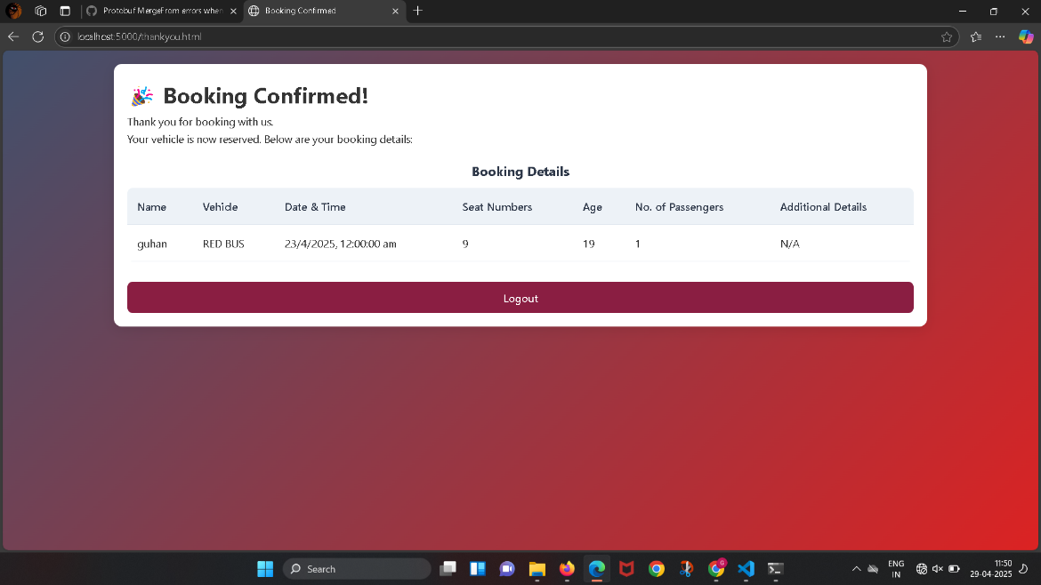

Fig: 4.2.4 Showing Booking Page

CHAPTER 5

CONCLUSION

The Bus Booking Application successfully delivers a robust, user-friendly platform for bus seat reservations, leveraging modern web technologies such as Node.js, Express.js, MySQL, HTML, CSS, and JavaScript. It automates the booking process, provides real-time seat availability, and ensures secure user authentication, significantly improving efficiency over traditional manual systems. The application's responsive interface and comprehensive error handling enhance accessibility and reliability for users across devices. Its modular design facilitates easy maintenance and scalability, while the MySQL database ensures secure and efficient data management. The project not only addresses practical transportation challenges but also demonstrates the effective integration of frontend and backend technologies. Future enhancements, such as support for multiple buses, payment gateway integration, and advanced scheduling, could further elevate its functionality. This application serves as a valuable proof-of-concept for web-based reservation systems, offering a scalable foundation for future innovations in the transportation sector .This project underscores the potential of web-based solutions to address real-world transportation challenges, demonstrating seamless integration of frontend and backend technologies. The application's success in providing an intuitive booking experience highlights its practical utility and technical robustness. Future enhancements, such as integrating payment gateways, supporting multiple bus schedules, and adding real-time notifications, could further expand its capabilities. As a scalable foundation, the Bus Booking Application paves the way for innovative advancements in the transportation sector, serving as a model for efficient, technology-driven reservation systems.

CHAPTER 6

REFERENCES
- Node.js Documentation: https://nodejs.org/en/docs/, detailed backend runtime setup and server-side logic implementation.
- Express.js Documentation: https://expressjs.com/, guided RESTful API development and middleware usage.
- MySQL Documentation: https://dev.mysql.com/doc/, supported database design and query optimization.
- MDN Web Docs: https://developer.mozilla.org/, offered HTML, CSS, and JavaScript best practices.
- W3Schools Tutorials: https://www.w3schools.com/, provided practical frontend development examples.
- Stack Overflow: https://stackoverflow.com/, facilitated debugging and community-driven solutions.
- GitHub Documentation: https://docs.github.com/, aided version control and project management.
- REST API Design Guidelines: https://restfulapi.net/, ensured consistent and scalable API design.
- Web.dev by Google: https://web.dev/, provided web performance and responsiveness optimization tips.
- MySQL Workbench Manual: https://dev.mysql.com/doc/workbench/en/, assisted in database administration and schema design.

